Next Generation Bioinformatics Tools

Hesham Ali

Exercise Four

Objective: This exercise will review sequence assembly process and familiarize students with different parameters affecting the assembly process. It will also demonstrate how assembly is visualized.

Theoretical Background:
- Types of assemblers
  - overlap-layout-consensus (newbler, celera, edena) vs. De Bruijn Graph (Abyss, Velvet, Soap de novo)
  - de novo(Abyss, Velvet, Celera) vs. reference based (AMOScmp,454gsMapper)

- Sequencing Types
  - Single-end (reads from one end of the fragment)
  - Paired-end (sequenced reads from both ends of a fragment)

- Assembly parameters
  - Kmer size (k)
  - minimum overlap length (m)

- Assembly statistics
  - Size
  - Number of contigs (n)
  - N50

Part1: Example Assembly Run

mkdir day4
cd day4
abyss-pe k=20 name=test se=/data/day4/test_reads.fa

Input file format
The input file format is FASTA or FASTQ. To open the input file and see the reads type the following:
gedit /data/day4/test_reads.fa

Output files
Several output files are produced from the assembly process. The most important one is the contig file.

- test-se-contigs.fa

gedit test-se-contigs.fa

>0 99889 2001860
CTACGGCGAAGATAATGAGATCGGTAG …….

0 = contig id
99889 = length of contig
2001860 = total kmer coverage

- test-bubbles.fa and test-indel.fa

These files have candidate SNPs in the reads. In particular, the indel file has bubbles with indels, but contains only the branch of the bubble that was removed from the main assembly. This can be used to find indels when mapped to final assembly.

- coverage.hist

This file has coverage information.
Times appeared | Number of kmers
1 | 269106
2 | 6686
3 | 161
4 | 16
… | …

Assembly statistics

abyss-fac test-se-contigs.fa

n | n:200 | n:N50 | min | N80 | N50 | N20 | max | sum
1 | 1 | 1 | 99889 | 99889 | 99889 | 99889 | 99889 | 99889 | test-se-contigs.fa
What do these measures mean?

n | number of contigs
n:200 | number of contigs > 200bp
min | minimum contig size
N50 | length of a contig from a set of longer contigs whose combined length represent 50% of assembly.
n:N50 | number of contigs greater than N50 length
max | maximum contig size
sum | total assembly size (if multiple contigs, all lengths are added)

Ideally, we want to get least number of contigs, which are very long.

Process Overview:

In this exercise, different parameters are changed during the assembly process and the goal is to analyze the assembly output and find the best set of parameters. For one set of sequence reads, K-mer size, overlap size and number of processors can be changed. Number of processors doesn’t affect the quality of the assembly but can significantly alter the time to produce the result.

ABySS Assembler
Sequence Reads
Kmer size
Overlap size
Contigs
No. of
Proc.

Case Study1: What effect do kmer and overlap sizes have in the process of assembly?

Let us first change kmer size parameter in Abyss assembler. This assembler has “k=” switch, that can be assigned different kmer sizes. “k=25” means kmer size is 25.

Shown below is a ‘for loop’, that iterates from k=20 to k=30.

for k in {20..30}; do mkdir k$k; cd k$k; abyss-pe k=$k name=test se=/data/day4/test_reads.fa; cd ..; done

k=$k changes k-mer size from 20 to 30

All the outputs will be stored inside directories labeled as k20, k21, k22 ….. k30.

Next, let us run abyss-fac and compare the assembly results.
for x in `ls k*/ test-se-contigs.fa`; do echo $x; abyss-fac $x; done

This outputs the assembly statistics for output from all values of “k”. Here, we notice that the best result is given when minimum k is 20.

Also, notice that when the value for k is increased, the number of contigs will increase, which means there are multiple shorter contigs.

Next, let us change the overlap length size parameter in Abyss assembler. This assembler has “m=” switch that can be used to assign different overlap length sizes.

Shown below is a for-loop, that iterates from m=20 to m=30.

for m in {20..30}; do mkdir m$m; cd m$m; abyss-pe k=20 m=$m name=test se=../test_reads.fa; cd ..; done

m=$m changes overlap length

To compare the assembly results, abyss-fac is run for all the outputs in m20, m21, m22 … m30 directories.

for x in `ls m*/ test-se-contigs.fa`; do echo $x; abyss-fac $x; done

For all values of m, the assembly result is same.

Case Study2: Does the use of more processors always yield fast results?

In this case study, we will evaluate the relation between the number of processors and the assembly process. Although the quality of assembly remains unaffected, the time needed to complete the process varies with the number of processors.
Abyss assembler has “np=” switch to assign number of processors.

Following is a command to run the Abyss assembler with 2, 4 and 8 processors and record the time needed to run the assembly process.

for p in {2,4,8}; do mkdir proc$p; cd proc$p; time abyss-pe k=20 np=$p name=test se=../test_reads.fa; cd ..; done

Processors | Time to Finish
2 | 0m3.322s
4 | 0m2.941s
8 | 0m3.965s

We notice that increasing the processors from 2 to 4 reduced the time needed for assembly, however increasing it to 8 increased the running time. Hence, based on input size and parameters, the number of processor is to be chosen.

Case Study3: Assembly of paired-end data (approx. 10min)
In this case study, we will run the assembler for paired-end data. The paired end data can be available in two different ways, viz.
- In a single FASTQ file containing the pair or
- In two separate FASTQ files
  - Multiple fastq files can be placed in quotes
abyss-pe k=25 name=paired_end in=’file1.fastq file2.fastq’

abyss-pe k=25 name=paired_end in=’/data/day4/paired_end_1.fastq /data/day4/paired_end_2.fastq’

Part2: Visualization of assembly
In this exercise, we will align the reads with the contigs and visualize the depth of contigs, candidates for SNPs, etc.

Software Needed (already installed):
- Bowtie (http://bowtie-bio.sourceforge.net/index.shtml)
- Tablet (http://bioinf.scri.ac.uk/tablet/)

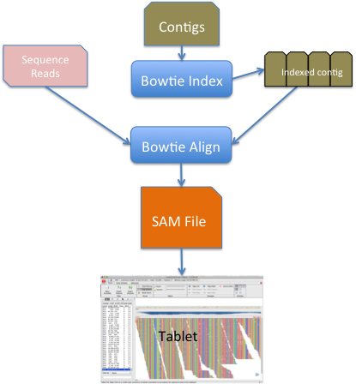

Steps for visualization (all in assembly directory)

Step1: Index all the contigs using bowtie indexor
bowtie2-build paired_end-3.fa paired_end-3.index

Step 2: Align all the reads to the indexed contigs (approx. 10 min)
bowtie2 -x paired_end-3.index -1 /data/day4/paired_end_1.fastq -2 /data/day4/paired_end_2.fastq -S paired_end-3.sam

Step 3: Index the contig file
samtools faidx paired_end-3.fa

Step 4: Convert sam to bam file
samtools import paired_end-3.fa.fai paired_end-3.sam paired_end-3.bam

Step 5: Sort the bam file
samtools sort paired_end-3.bam paired_end-3.bam.srt

Step 6: Index the sorted bam file
samtools index paired_end-3.bam.srt.bam

Step 7: Open Tablet software from Desktop. Cancel any update options.

Step 8: Load Sorted Bam file and the Contigs file in the visualization software (Tablet)
Click on Open Assembly and give path to the sorted bam file from step6 and the contigs file (paired_end-3.fa).

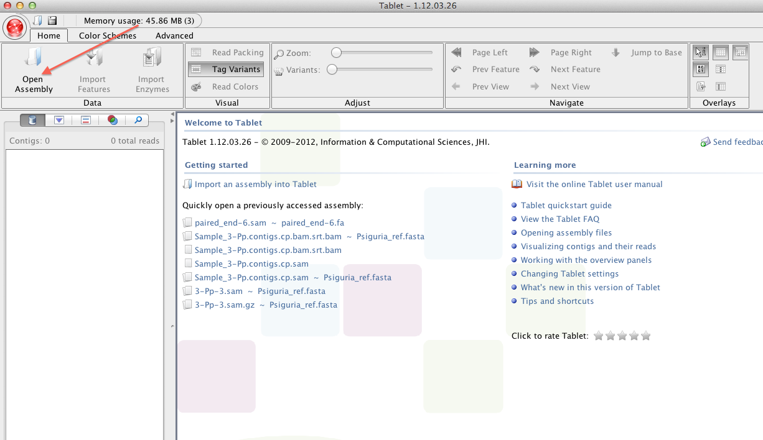

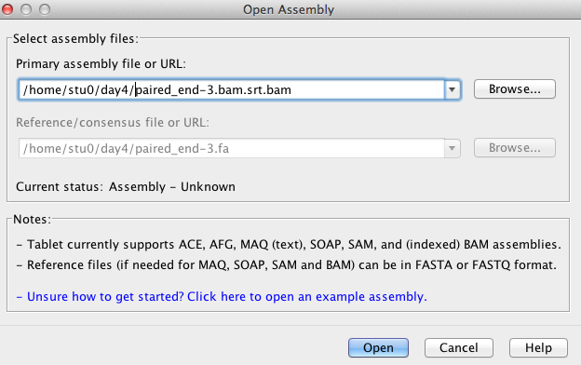

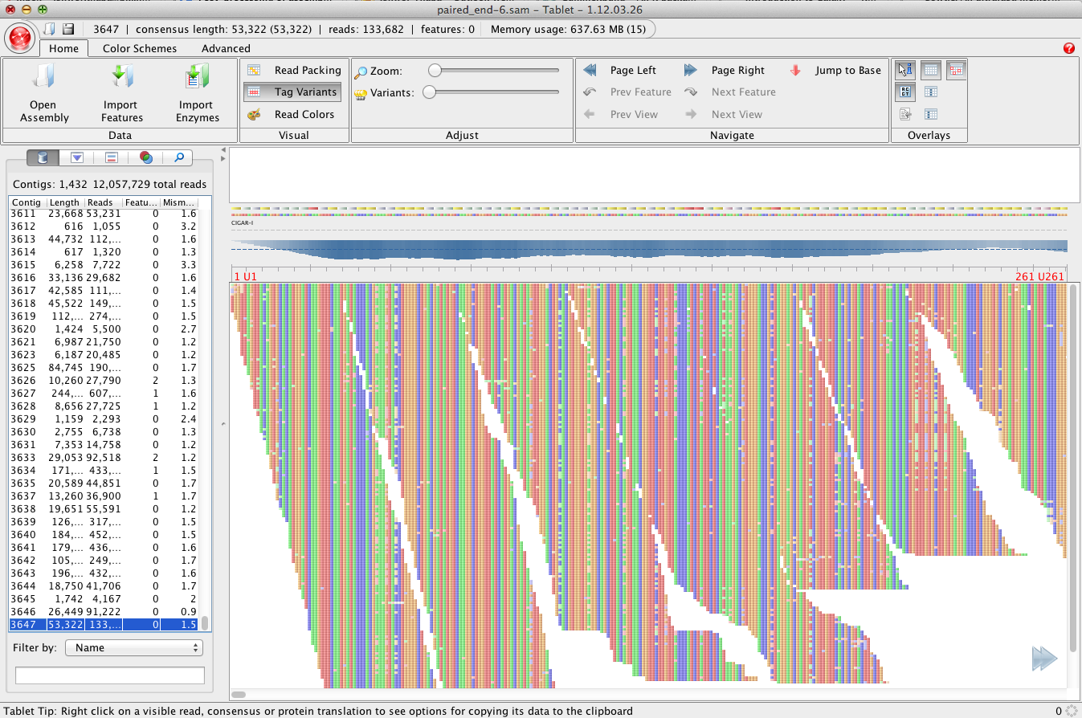
Part3: Cascading of assemblers (Meta-genomics or multiple chromosomes)
Sometimes, sequence reads can come from multiple chromosomes/organisms. Can we cascade reference-based assembly with a de novo assembly?

Yes, we can first separate reads by aligning it to reference chromosomes/organisms and separate reads based on these alignment. After the reads are separated, we can perform de novo assembly.

Step 1: Creating bowtie index of reference chromosome or organism

bowtie2-build /data/day4/reference.fasta reference.index

Step2: Align the reads using bowtie

Here is an example of paired end data again. file1.fastq and file2.fastq are two fastq files for paired end data. The output file is file.sam.
bowtie2 –x reference.index -1 /data/day4/paired_end_1.fastq -2 /data/day4/paired_end_2.fastq –S alignment.sam

Step3: Get the mapped read ids from the alignment file

cat alignment.sam| grep -v '^@' |grep 'reference' |cut -f1 > filter.ids

Step4: collect sequences from original fastq files with the ids from filtered list.

fastqselect -infile /clab_bdb/course_supplement/workshop/data/day4/paired_end_1.fastq -name filter.ids –outfile paired_end_1.filtered.fastq

fastqselect -infile /clab_bdb/course_supplement/workshop/data/day4/paired_end_2.fastq -name filter.ids –outfile paired_end_2.filtered.fastq

This will produce paired_end_1.filtered.fastq and paired_end_2.filtered.fastq. These fastq files have filtered set of reads after mapping to reference sequence.

Step5: Fastq files from step4 can be used to do de-novo assembly as shown in previous section.

abyss-pe k=25 name=paired_end in=’paired_end_1.filtered.fastq paired_end_2.filtered.fastq’

